Chelaque Estates Homeowners’ Association
Marina Use Policy and Procedure

- Introduction

A. As set forth in the By-Laws of Chelaque Homeowners’ Association, Inc.:

- Article V, Section 1 (a), “The Board of Directors shall have power to adopt and publish rules and regulations governing the use of the Common Area and facilities and the personal conduct of the members and their guests thereon.”

- Article X, “The Board of Directors shall have the right to adopt and amend rules and regulations governing the details of the operation, use and maintenance of the Common Areas.”

In past years, adopting a use policy for the Marina was not deemed necessary because all of the available docking areas were not utilized. However, as we approach full capacity, the Board of Directors felt it was time to adopt a clear policy prior to reaching that point.

B. In accordance with the Amended and Restated Declaration of Covenants, Conditions and Restrictions for Chelaque Estates:

- Article III, Section 1, . . .”The Association may charge a reasonable admission and other fees for the use of any facility situated upon the Common Area.”

The following use policy is being put in place with the goal of making the Marina common area financially self-sufficient. There are many owners that due to having private docks, being non-residents, or preferring to launch their watercraft, do not make use of the Marina. This policy is derived from input from many owners and we feel rightfully puts the cost of maintaining this common area on those who actually use it. As less funds are needed from our general operating budget to maintain and operate the Marina, more funds can be placed into our road repair fund, which all owners benefit from and will need major investment in the near future. Fees collected may also make it possible to consider future expansion of the paved Marina parking area which will also help.

- Definitions

“Annual Reservation Period” refers to the period beginning May 1st and ending April 30th of the following year.

“Marina Committee” is a group appointed by the Chelaque Homeowners’ Association Board of Directors to oversee the Marina related common areas and is acting on behalf of the Chelaque Homeowners’ Association.

“Common Area” shall mean all real property owned by the Association for the common use and enjoyment of the Owners.

“Owner” shall mean and refer to the record owner, whether one or more persons or entities, of the fee simple title to and lot which is a part of the Properties.

“Association” shall mean and refer to Chelaque Homeowners’ Association, Inc., its successors and assigns.

“First come, first serve” refers to a non-reserved docking area in which the owner of a watercraft has no return rights upon vacating that docking area. Once vacant, it can immediately be occupied by any other properly registered watercraft. No personal items may be left behind, tied to or sitting on the dock area.

“PWC” refers to Personal Watercraft such as a Jet Ski or Wave Runner.

“Reserved Slip” refers to the covered Marina docking area consisting of 40 slips as identified on the Covered Dock Map (Reference Exhibit Mar/03b - Covered Dock Map). These docking areas shall ALL be marked as RESERVED.

“Right of first refusal” shall mean that owner is given the right to renew their reservation for a covered docking area for the following annual reservation period provided that all other conditions are satisfied.

III. Admission of Watercraft to the Marina

A. Only watercraft in good seaworthy condition will be admitted. Powered watercraft must be able to operate under their own power.
B. All watercraft must be registered with the Marina Committee prior to occupying any docking area (Reference procedure Mar/01, Section IV, Paragraph A).
C. Owners are encouraged to maintain insurance on their watercraft. The Association is not responsible for any loss due to weather, theft, vandalism, or any other cause.
D. Guests of owners shall be allowed to use first come, first serve non-reserved uncovered docking areas for a period not to exceed 4 days. Guests of owners may park boat trailers in the Marina parking area for a period not to exceed 4 days.
E. Floating PWC docks will only be permitted in reserved covered docking areas. The size of any PWC dock must not exceed that allocated to the docking area.
F. Any structure that must be attached to the community dock with nails, bolts, screws or clamps may only be used in a reserved covered docking area AND only with prior written approval from the Marina Committee. To obtain written approval, the owner must first provide a written description of the exact size of the structure, detailed plans on how the structure will be attached to the community dock, as well as a signed statement that the owner will be financially responsible for any repairs needed to the community dock as result of the attached structure.

IV. Covered Docking Area Assignments

A. Each of the 40 covered docking areas shall be available to be reserved for the annual reservation period from May 1 to April 30. The Marina Committee may maintain one of the covered slips for use by the Marina jon-boat used primarily for trash boom cable adjustments. The annual reservation fee, per the Covered Dock Reservation Request on the Chelaque website, is due no later than April 1 for the following year. This fee is set by the CHOA Board of Directors and is based on current operating costs, as well as projected maintenance and upgrade costs. All funds collected from reservation fees shall be used only for Marina operation costs. Any excess shall be set aside for future Marina area repairs, upgrades and parking lot expansion.
B. Owners requesting a reserved dock slip shall complete and submit a Covered Dock Reservation Request form annually with the reservation fee (Reference Exhibit Mar/03a – Covered Dock Reservation Request). The form can be obtained online at the Chelaque Estates website. The completed form is to be submitted with the annual fee directly to the Marina Chairman no later than April 1 of each requested year. Note: As per the Amended and Restated Declaration of Covenants, Conditions and Restrictions for Chelaque Estates, Article III Section 1, “The use of the Common Area shall be limited to those owners who are not delinquent with regard to any Assessments rendered by the Association or other charge due to the Association,” only owners in good standing may request a reserved dock slip.
C. In the event that owners greater than the slips available send payment to reserve a covered docking area for the annual reservation period, the owners with existing reserved slips shall have right of first refusal for the dock slips they are currently occupying, provided that they have followed the reservation procedures per Section IV Paragraph B above. Owners who do not receive a reserved slip will be refunded the full reservation fee paid and their name(s) will be registered on a “Marina Slip Waiting List” maintained by the Marina Committee. Owner(s) will be entered on the Marina Slip Waiting List in the order of the earliest postmark date on the envelopes received with reservation request and fee.

D. If reservation requests and payments have been received for all covered docking areas and a covered docking area becomes available for reservation in the future, the next owner registered on the Marina Slip Waiting List shall be notified of the availability by mail and shall have 15 days from the date the notice was mailed to submit a Covered Dock Reservation Request form with the annual reservation fee to the Marina Committee. In the event that no response is received from the first registrant on the Marina Slip Waiting List, the next registrant will be notified of the availability, and so on.
E. After the April 1st deadline, should covered docking areas remain unreserved, owners may at any time submit a Covered Dock Reservation Request form for the remainder of the annual reservation period to the Marina Committee. Annual reservation fees will not be prorated, however the owner shall have right of first refusal for the following year’s covered docking area reservation process.
F. Reservation fees from owners are non-refundable unless all available slips are reserved and there is an accepted and paid slip reservation from the next owner on the Marina Slip Waiting List. Any reservation fee refunds will be pro-rated from the next month following the re-reservation of the slip through April.
G. With payment, an owner may request a preferred covered docking area (Reference Exhibit Mar/03b - Covered Dock Map). The Marina Committee may consider these requests when assigning locations, however, specific location requests cannot and will not be guaranteed.
H. After the reservation requests and payments are received, the Marina Committee will assign a dock slip to the requestor. The Marina Committee will record the assignment on the Covered Dock Slip Assignment Sheet (Reference Exhibit Mar/03c – Covered Dock Slip Assignment Sheet).
I. The Marina Committee will notify the requestor as to his dock slip assignment number.
J. Each owner may occupy only one covered docking area, regardless of the number of properties owned, and it shall be for their sole use only.
K. Owner shall not be allowed to transfer or sub-let their reserved slip to any other party(s).
L. Any watercraft which is improperly docked in a covered docking area marked as RESERVED may be moved by the Association without any prior notice to the owner.
M. The Association is not responsible for any damage to a watercraft or attaching cables or locks as a result of moving it.

V. Uncovered Docking Areas

- Uncovered docking areas along the outside of the covered docking areas shall remain first come, first serve.
- The very first usable docking area is along the walkway, nearest the shoreline; boat launch side is reserved for temporary tie-up for those launching or retrieving watercraft. All remaining docking areas along the walkway will be first come, first serve.

Exhibit Mar/03a

Chelaque Estates Homeowners’ Association

COVERED DOCK RESERVATION REQUEST

May 1 – April 30 Reservation Period with a $TBD annual fee. No pro-rated fees.

Please refer to the Chelaque Estates Marina Use Policy and Procedure (Mar/03) for complete rules regarding this request.

Owner Name: _____________________________________________________
Phase/Lot Number: _____________________________________________________
Mailing Address: _____________________________________________________
_____________________________________________________
Email Address: _____________________________________________________

Boat Length: _________ feet

Requested Slip Number (Optional – See Covered Dock Map): _________________________
The Marina Committee may consider these requests when assigning locations, however, specific location requests cannot and will not be guaranteed.

This request must be accompanied by a check for the amount of fee above, payable to CHOA. Reservation requests are due prior to April 1 of requested year.

Mail this form with your payment to:
CHOA
599 Proffitt Ridge Rd.
Mooresburg, TN 37811
ATTN: Marina Committee

________________________________________________________________________

Slip Number Assigned (Completed by Marina Committee): ____________

Exhibit Mar/03b

Chelaque Estates Homeowners’ Association

COVERED DOCK MAP

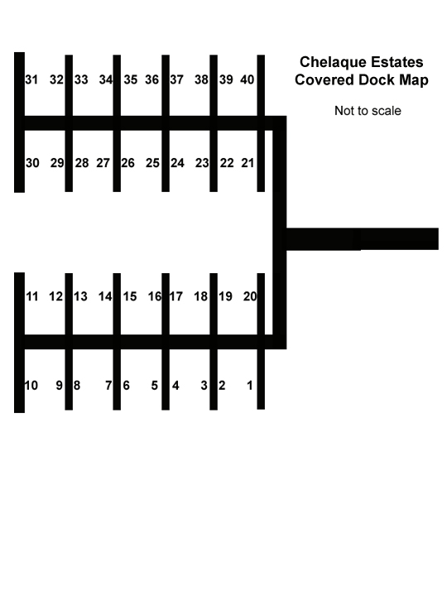

Exhibit Mar/03c

Chelaque Estates Homeowners’ Association

COVERED DOCK SLIP ASSIGNMENT SHEET

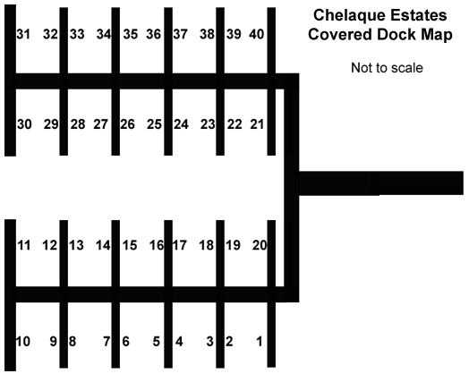

1. _______________________
2. _______________________
3. _______________________
4. _______________________
5. _______________________
6. _______________________
7. _______________________
8. _______________________
9. _______________________
10. ______________________
11. ______________________
12. ______________________
13. ______________________

14. ______________________
15. ______________________
16. ______________________
17. ______________________
18. ______________________
19. ______________________
20. ______________________
21. ______________________
22. ______________________
23. ______________________
24. ______________________
25. ______________________
26. ______________________
27. ______________________

28. ______________________
29. ______________________
30. ______________________
31. ______________________
32. ______________________
33. ______________________
34. ______________________
35. ______________________
36. ______________________
37. ______________________
38. ______________________
39. ______________________
40. ______________________

